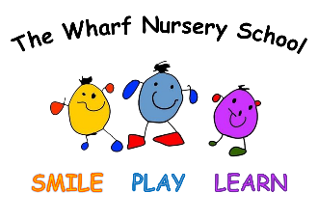
Behaviour Principles
Valid From: October 2026
Review: October 2027

Next Review Due: January 2023
At The Wharf Nursery School, we believe that behaviour is a form of communication and that every child deserves to feel safe, valued and understood. We are committed to creating a nurturing environment where children can develop the social and emotional skills they need to thrive.

1. Positive relationships are at the heart of everything we do
- Warm, trusting relationships support children's emotional wellbeing and help them feel secure enough to learn. We work closely with families to ensure a consistent and supportive approach.
2. Every child is treated with dignity and respect
- We celebrate individuality and recognise that children develop at different rates. We promote kindness, empathy and respect for others.
3. Behaviour is taught, modelled and supported
- We help children learn the skills they need to manage emotions, solve problems and build positive relationships. Adults model the behaviours and attitudes we wish to see.
4. Children's emotional needs are understood
- We recognise that behaviour often communicates a need, feeling or experience. We seek to understand the reasons behind behaviour and provide appropriate support.
5. Consistency creates security
- Clear boundaries and expectations help children feel safe. Staff respond to behaviour in a calm, predictable and developmentally appropriate manner.
6. Inclusion underpins our practice
- We recognise that some children may require additional support to regulate their behaviour and emotions. We make reasonable adjustments to meet individual needs and ensure every child can succeed.
7. Positive behaviour is encouraged and celebrated
- We acknowledge effort, kindness, resilience and cooperation. We focus on helping children develop intrinsic motivation and positive self-esteem.
8. Physical and emotional safety are paramount
- We support children to keep themselves and others safe. Any incidents are managed sensitively and proportionately, with children's wellbeing at the centre of decision making.
Our Commitment
Through nurturing relationships, consistent expectations and an understanding of child development, we aim to help all children develop confidence, self-regulation, empathy and a lifelong love of learning. These principles were developed alongside our Behaviour Policy.

Agreed by FGB: October 2026

